Mobile User Experience

6MMCS001W

Report

Group Number: 33A

Team Members:

|  |  |  |
| --- | --- | --- |
| Name | IIT No | UOW No |
| Resindu Navoda | 2016352 | W1654203 |
| Suganthy Kangaiveniyan | 2017800 | W1699842 |
| Anojini Amaranathan | 2016437 | W1654577 |
| Weligama De Silva | 2016320 | W1654189 |

Links to WebSite:

URL:

# Content

Content 3

1. Discussion of UI and application of UX principles 4

1.1 Information architecture 6

a. Design 6

1.2 Colour balance/composition/graphics/consistency 8

Design 8

Code to achieve good colour balance & ensure consistency 9

1.3 Typography / consistency 9

Design 9

Justification 10

1.4 Photography / consistency 11

Design 11

Code to achieve good colour balance & ensure consistency 12

1.5 Gestalt principles grouping 13

2 Design and implementation of features 15

2.1 Eye catching introduction 15

2.2 Incorporation of a short video 16

2.3 POI 16

2.4 List creation & sorting and filtering widgets 17

2.5 Booking form 18

2.6 Favorites list 19

2.7 System feedback 20

2.8 Scores & points gained 21

2.9 QR, Scores & points gained 21

# Discussion of UI and application of UX principles

Kart Zone introduced another technology for launching the web app by an online supermarket in Sri Lanka.

Via this new web app customer can order the goods online and view ongoing Saver promotions as well as Cyber weekend promotions, contact us and send in any comment or suggestions they may have.

UX Design relates to the user’s feelings and product developments. UX stands for UserExperience. When a user uses a product, he/she may experience a good or a bad or both feeling about the product. UX is the way a person feels when they communicate with a program. This includes a website, web application, desktop software, and basically any form of interaction between humans and devices.

To put it simply, UX is critical as it seeks to satisfy the needs of the user It is intended to provide positive experiences that will keep users loyal to the product. In fact, a positive user experience helps us to identify the most suitable business success user experiences on our website.

Principles of UX Design

1. Meet the user’s needs

The foremost of all UX design principles is to focus on users throughout the design process. The term user experience itself makes it clear that your work needs to center on improving your users’ experience with your product or service.

When we were decided to do online supermarket, First We analyze the online customers’ needs and their expectation levels. They need user friendly and useful with groceries goods app.

1. Have a clear hierarchy

It is easy to take hierarchy for granted, but it is a UX principle that ensures smooth navigation throughout a design. There are two chief hierarchies that you need to note. First comes the hierarchy that is associated with how content or information is organized throughout the design.

Figure 1: IPad Navigation

Figure 2: IPhone Navigation

when user open our app, there is a navigation bar that includes the main sections. This is the primary hierarchy**.** When you click or hover over this bar, you will note further sub-categories of content open up, taking you deeper into the app. These are the secondary menus.

1. Feedback

Design should be interactive by nature. So, when a user clicks on something, he’ll need a response from the product to understand that his command has been received. Feedback is a crucial way to encourage communication between humans and machines.

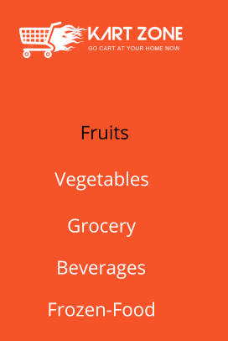

Figure 3:IPhone Feedback. Figure 4: IPad Feedback

1. Confirm the order

Accidents happen all the time. Our design help correct this, though, because you don’t want to give the user a poor experience. This makes confirmation another one of the essential UX design principles.

Figure 5:IPad Confirmation Figure 6: IPhone Confirmation

UX principles helps us to achieve a good aesthetical result, appealing to the target audience of the mobile web app, with good visual balance between all the UI elements, making content legible, clear and discoverable.

## 1.1 Information architecture

### a. Design

Figure 7: Page link from HomePage

The Information architecture we found relevant to us is the Geographical Information architecture. The app we are developing is online supermarket app for buyers. This app encourages peoples to buy goods through the online.

For the Mobile Information architecture, we have sections tied together by the toolbar menu, this allows the user to quickly navigate and try out many features and functionality of the app on the first opened itself.

This architecture used here is the Tabbed View. The mobile app has been modularized and the pages were organized to a particular structure that will be beneficial in the extensibility of the app.

As mentioned above the app uses the Tabbed View for easy and intuitive navigation.

Figure 8: Tabbed View

Codes

When multiple pages are using the same style its, redundant to use reuse them on each page. Rather it would be much more efficient to make sure common elements and templates are loaded for all the pages.

Figure 9: Navigation

## 1.2 Colour balance/composition/graphics/consistency

### Design

Explain the colour combination, the composition (visual structural elements) and graphics (images, logo, icons) you used to ensure the proposed web site is appealing for its purpose, it reveals it identify and complies with the brand. Good aesthetical result such as good visual balance between all the UI elements (background, header, footer, text, borders etc.) and also ensure good legibility of the mobile web app.

The theme color of our app is orange. Orange color combines the energy of red and the happiness of yellow. It represents enthusiasm, fascination, happiness, creativity, determination, attraction, success, encouragement, and stimulation. Orange increases oxygen supply to the brain, produces an invigorating effect, and stimulates mental activity. It is highly accepted among young people. As a citrus color, orange is associated with healthy food and stimulates appetite Orange is a very hot color to human eye and It has high visibility. Orange is very effective for promoting food products.

In the application Black color is used mostly on white background. This combination is used for headlines, body content etc. Dark grey on white background is also used for some of the body content. As shown in Figure 4 there is no accessibility issues when using dark grey on white background since it passes the minimum contrast ration of 4.5.

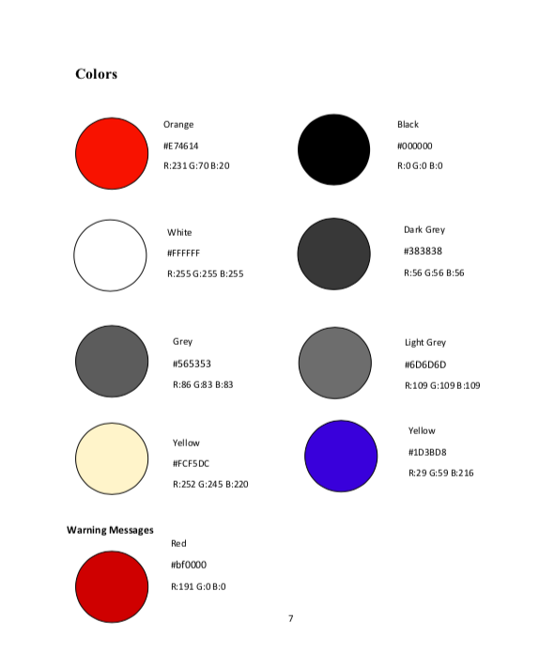

Figure 10: Colour Palette Figure 11:Colour Contrast Checked

### Code to achieve good colour balance & ensure consistency

Figure 12: Colour Balance and Consistency across the app

## 1.3 Typography / consistency

### Design

**1. Headline: Open Sans Bold**

Font size mobile: 24px and up

Line height mobile: 120%

Font size tablet: 32px and up

Line height tablet: 90%

Text: upper case

Letterspacing: 0 Color: #000000

**2. Sub headline: Open Sans Semibold**

Font size mobile: 9-16px

Font size tablet: 10-18px

Line height: 120% Text: upper and lower case

Letterspacing: 0

Color: #5c5c5c

**3. Bodycopy: Open Sans Regular**

Font size mobile: 9-16px

Font size tablet: 10-18px

Line height: 160%

Text: upper and lower case

Letterspacing: 0

Color: #383838

**4. Labels: Open Sans Light**

Font size mobile: 9-16px

Font size tablet: 12-18px

Text: upper case

Line height tablet: 120%

Letterspacing: 0

Color: #7d7d7d

### Justification

Within the mobile application Open Sans font type is used to make the content within the application more readable and to look modern and classy.

Open Sans Bold is used for the headlines to emphasize the headline and Open sans semi bold is used for the sub headlines to emphasize the sub headlines. Open sans light is used for the labels as it expresses clean and neat mood.

For the bodycopy open sans light is used to make the content easy to read for any person. This font type is also readable for the visually impaired person.

**Header1**

**Header2**

Header3

Header4

## 1.4 Photography / consistency

### Design

Figure 13: Iconography

We decided to present images as thumbnails images in our app. A thumbnail (“thumb” for short) is a compressed preview image of the original that is used as a placeholder. Depending on the platform, a thumbnail image should have a certain size.

The biggest advantage of thumbnail images is their reduced file size compared to the original image. A website will have significantly faster loading times if its range of image and video content is initially displayed in the form of thumbnails. Internet users decide for themselves which content they want to see, and load the actual, original image or content by clicking on the thumbnail.

The small file size of thumbnails makes it possible for us to offer the customers a lot of content immediately without increasing the loading time of the page.

* **Space savers:** Preview images allow user to present an overview of different media content in a small space.
* **User-friendliness:** Images have the great advantage that they can be captured very quickly, thumbs structures a website so that users can quickly find their way around it.
* **Interactivity:** Thumbnails engage the user with the website – usually by clicking on a thumbnail image.

### Code to achieve good colour balance & ensure consistency

Figure 14: Image Consistency

## 1.5 Gestalt principles grouping

**Design**

Proximity

Figure 15:Proximity Image

**Proxmity:** In Best Deals Objects are close to another appear to form groups has been applied by aligning the item’s name and item’s prices close to the main paragraph or aligning the image close to the image title creates groups.

Similarity

Figure 16: Similarity of Image

And also, **Similarity** is applied by the Font size, image size and the button size are maintaining similarly. And here, continuity is applied in the home page. We can scroll down the page and user can able to view the details.

Closure

Figure 17: Closure Image

In addition, **closure** is applied by drawing a line between the navigation buttons and the main body of the page. The separating text and images and later by separating the main body of the page and footer.

Continuity

Figure 18: Continuity Image

**Figure/Ground** is applied in capacity of how the eye can recognize the difference between shapes through the background of the design.

# 2 Design and implementation of features

In the sections below provide and explain the proposed design and the code you wrote to create the following main features and functionality of the mobile web app.

## 2.1 Eye catching introduction

We gave introduction about our app through the sliders in home page.

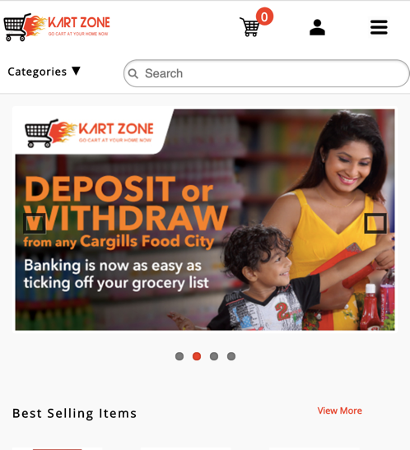

Figure 19: Eye Catching introduction

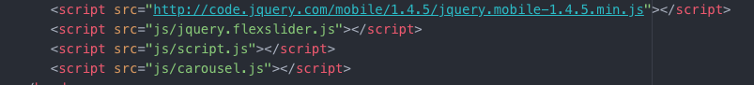

Figure 20: Eye Catching code 1



Figure 21:Eye Catching code 2

## 2.2 Incorporation of a short video

Incorporation of the short video is on wrap-up video of the summary of the application, where the user is at the convenience of taking in the whole idea of the application by having a simple walk through into the application.

How this has been integrated in iPhone and iPad?

## 2.3 POI

User can give a rating to items by giving the stars and comments to items in the rating page. The user can navigate the favorites list page by clicking on My Favorites on the overflow menu of account. The items favorite by the user will be listed there. The user can remove favorites items. The user will be able to email the favorites list by clicking on the export list button.

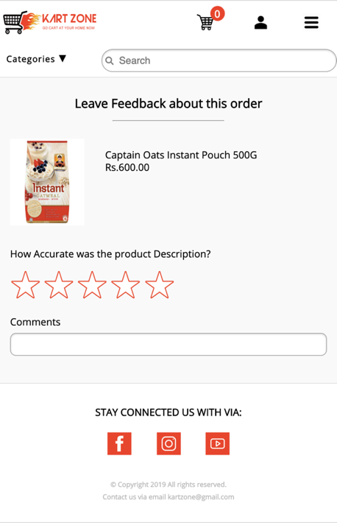

Figure 22:Rating Page Figure 23: Favourites Page

## 2.4 List creation & sorting and filtering widgets

We used Sorting in Best-Selling Page. From their we sort the items according the number of quantities for each item, for that we took a sum of quantity for each item and view the item details. User can able to buy from that page also from here user can easily interacted with our app.

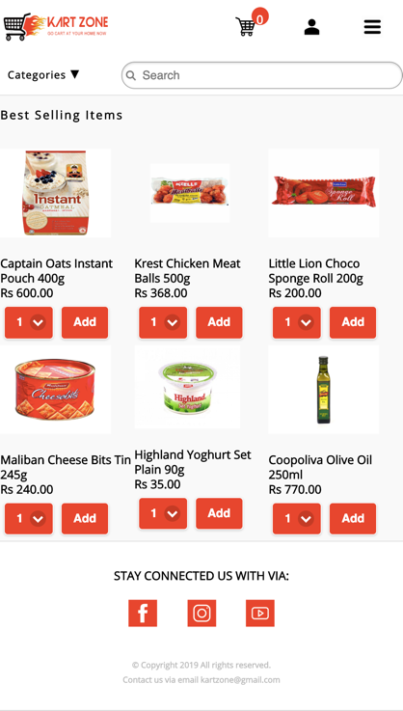

Figure 24: Best Selling Pages with Sorted

## 2.5 Booking form

In our application we have the user registration form.

Figure 25: User Registration Page

## 2.6 Favorites list

User can add an item to favorite list by clicking the Add to favorites button in the item page. The user can navigate the favorites list page by clicking on My Favorites on the overflow menu of account. The items favorite by the user will be listed there. The user can remove favorites items. The user will be able to email the favorites list by clicking on the export list button.

The user’s email address which was captured in registering will be the default email address of emailing the list. The user can also change the email address he/she wants to email the favorites list. In this case the inputted email address is validated.

When the user changes the orientation of the device, he will be able to experience a larger version of the list and the list items showed at once will be reduced. The user will able to experience a bigger and very clear version of the list in iPad and a little smaller sized version of the list components in iPhone.

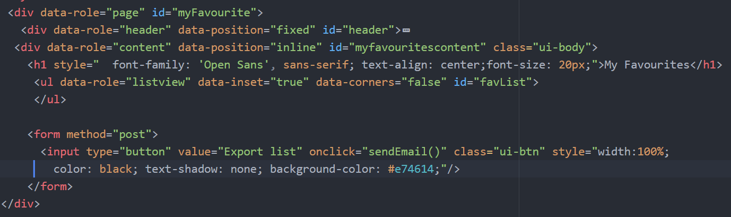

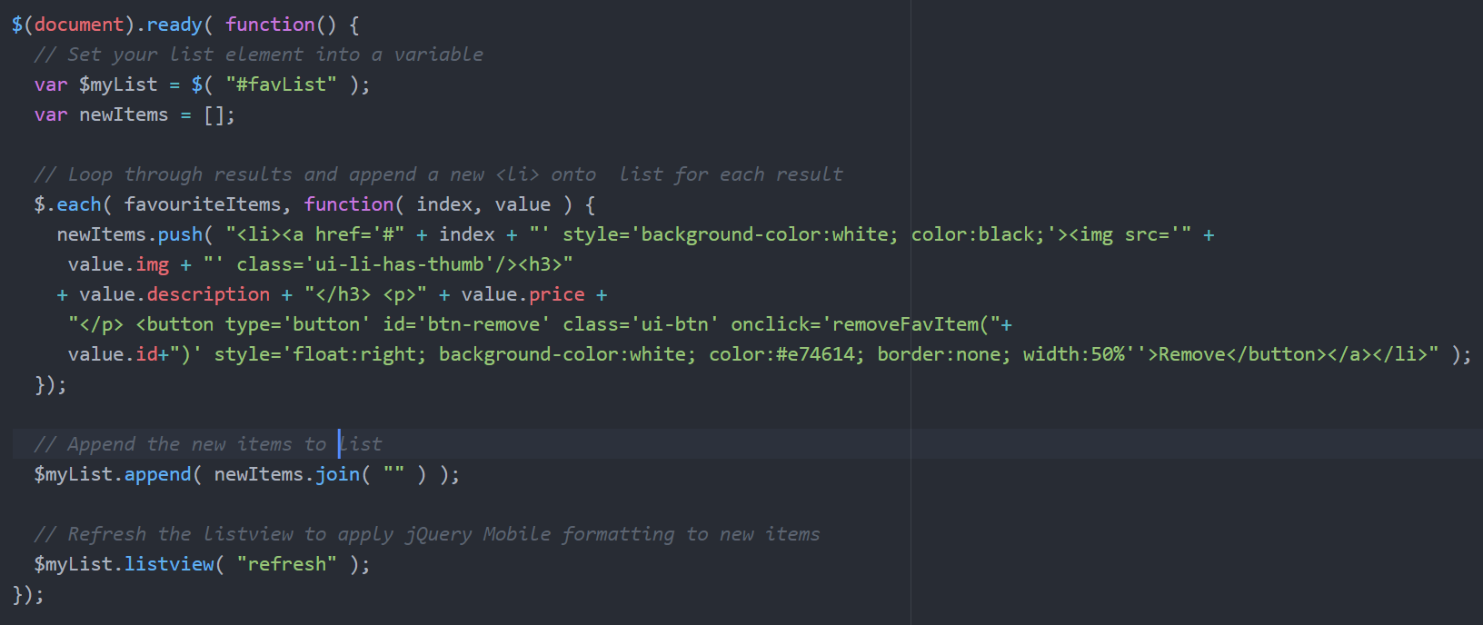

## 2.7 System feedback

Once the user completes the payment, they can go to my order page and from their they can click the leave feedback button and they can give the feedback for each item.

Figure 26: Leave Feedback Page

## 2.8 Scores & points gained

We introduced loyalty points to our user. Loyalty points means when they purchased from our online supermarket, from their total amount we are getting loyalty points as like each Rs 500 we are giving one points to them like wise they will earn points

And another way to earn loyalty points, from the QR code scanning they can earn.

From this we are marketing our partner’ show rooms, when our user went to that particular shop and purchased after that from their they can have a QR Code and user can scan that code and they can earn loyalty points.

Figure 27: Loyalty Points Page

## 

## 2.9 QR, Scores & points gained

Any user of this kartzone application can visit local stores (which were paid to get promoted via kartozne app) and purchase items and scan the QR code printed at the end of their bill.After they scan,they can add particular amount of loyalty points to the account and users of kartzone application will be able to use those loyalty points when they do a online purchase of products through our application.

